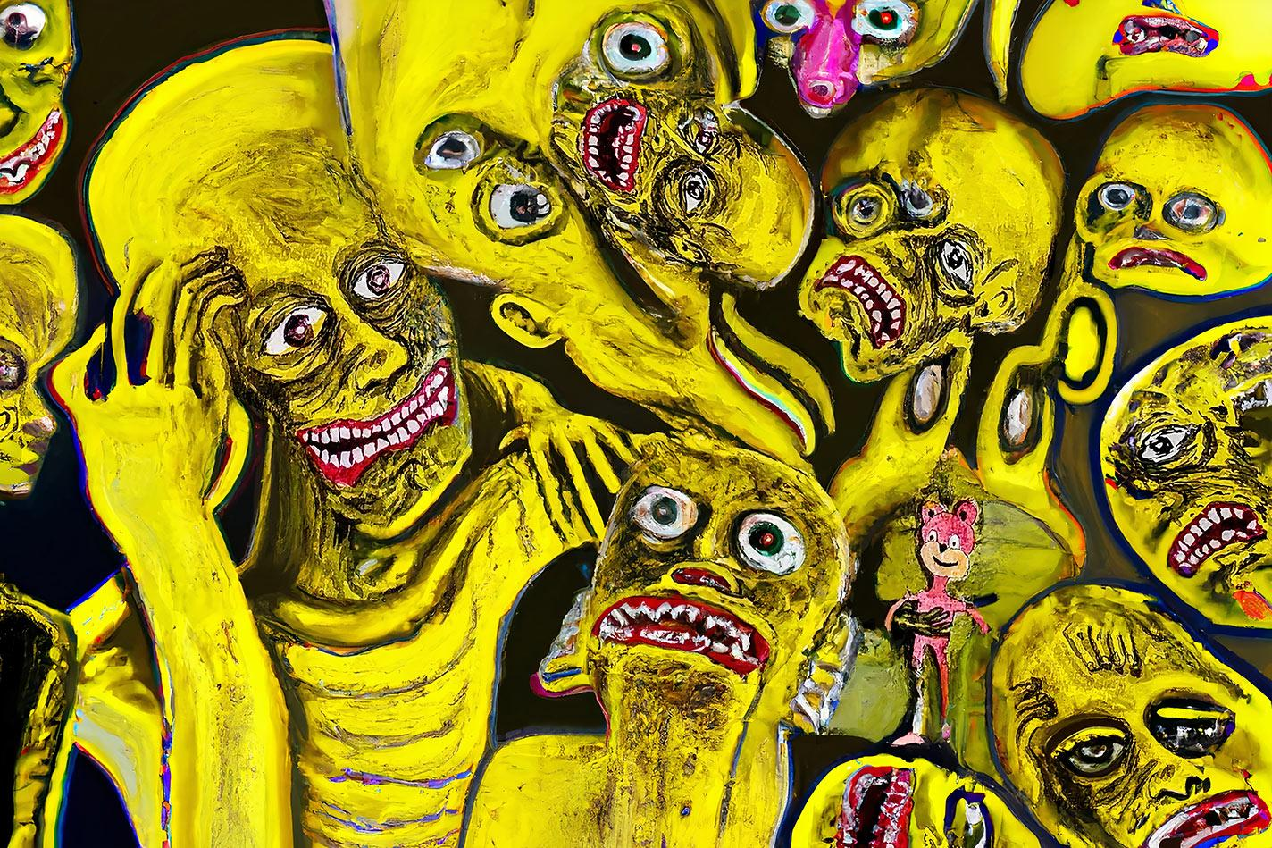

CrazyPepe
─
Pepe Magaña
@CrazyPepeEth / Twitter
CrazyPepe.com

Pepe Magaña
Pepe Magaña, also known as CrazyPepe, is an artist and software developer hailing from Mexico. After moving to France in 2007, he worked in various business ventures as a developer. However, it was during the lockdown in 2020, brought on by the pandemic, that Pepe had the opportunity to spend quality time with his son, ErrorSkull, and rediscovered his passion for art. Since then, he has dedicated a significant portion of his time to creating art.

Overview
As an artist, Pepe follows an intuitive and uninhibited approach to painting. He doesn't plan his artworks or rely on reference photos; instead, he allows the painting to guide him on an emotional and instinctual journey. This process of free expression serves as a means of communication, enabling him to convey the depth of his emotions and experiences.

Pepe's art emanates from a place of genuine emotion and intuition. By embracing this unrestricted method, he produces vibrant and energetic paintings that reflect the authenticity of his creative spirit. He believes that art should be an honest expression of oneself, enabling others to connect with it on a personal and meaningful level.

Throughout his life, Pepe has faced various challenges. From growing up with a mother who was a philosopher and a father consumed by money and power, to overcoming dyslexia and struggling with addiction, his journey has been marked by resilience and determination. Escaping a tumultuous environment and becoming a father himself, Pepe has found solace and inspiration in his artistic pursuits.

Pepe's art may be unconventional and sometimes challenging, but it is a reflection of his personal experiences and emotions. His work explores the depths of his psyche, drawing inspiration from the monsters of his childhood nightmares and the triumphs of his personal growth. Through painting, he has found healing, strength, and the ability to express his truth.

Today, Pepe continues to create art, having produced over 200 paintings with inks since his rekindling with the creative process. His art is a testament to the resilience of the human spirit and the power of self-expression.

Phygital
- https://makersplace.com/product/the-old-man-the-city-1-of-1-475355/
- https://makersplace.com/product/ideological-conflict-1-of-1-475344/
- https://makersplace.com/product/scrolling-through-shadows-1-of-1-475349/
- https://makersplace.com/product/the-big-lie-1-of-1-475345/
- https://makersplace.com/product/cosmic-canvas-1-of-1-475347/
- https://makersplace.com/product/self-portrait-1-of-1-475348/
- https://makersplace.com/product/i-can-fly-1-of-1-475346/
- https://makersplace.com/product/insomnia-1-of-1-475350/
- https://makersplace.com/product/beneath-the-event-horizon-1-of-1-472937/
- https://makersplace.com/product/ethereal-identity-1-of-1-472936/

