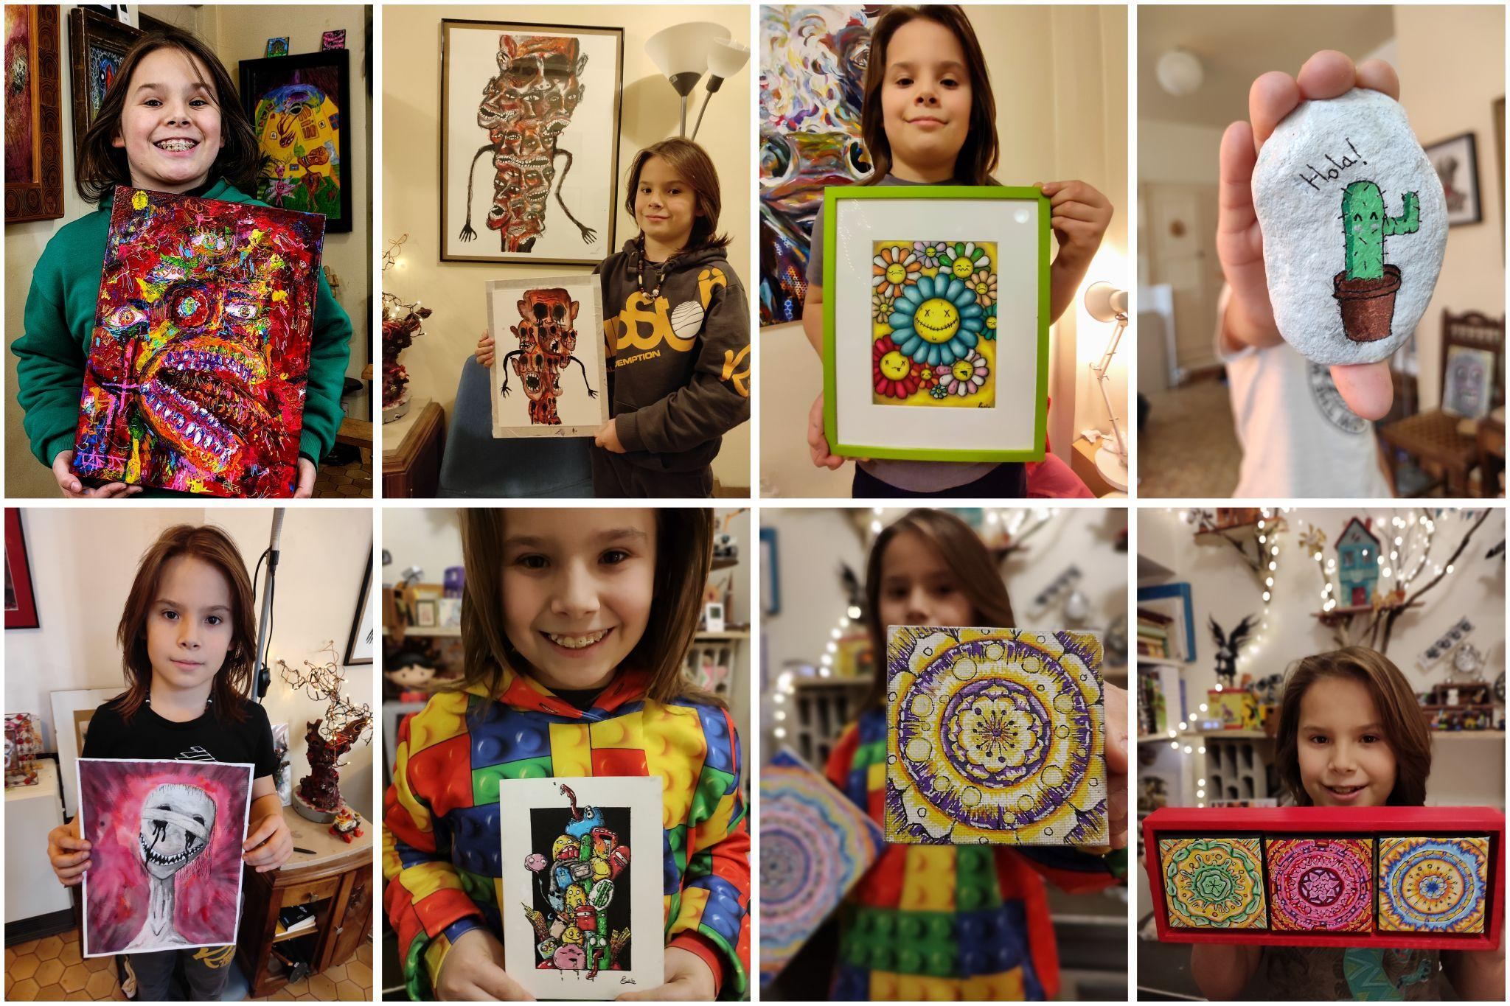

ErrorSkull
─
Paolo Magaña
@ErrorSkull / Twitter
ErrorSkull.com

Paolo Magaña
ErrorSkull, also known as Paolo Magaña, is a young and talented artist with a passion for the surreal and strange. At just twelve years old, Paolo demonstrates a profound love for artistic exploration beyond his years.

Overview
Paolo's artistic journey revolves around delving into the world of the surreal through his art. With a vivid imagination and a unique perspective, he creates pieces that push the boundaries of reality. His artworks are filled with creative details and nuances, transporting viewers to a realm that exists beyond our ordinary perception.

Through his art, Paolo seeks to unlock the mysteries of the strange and unusual. He invites others to join him on a journey of discovery, where the conventional rules of art are challenged and new possibilities arise. With each stroke of the brush or pen, Paolo adds depth and complexity to his creations, breathing life into the enigmatic worlds he envisions.

Despite his young age, Paolo possesses a remarkable understanding of the importance of artistic expression. He recognizes that art is a powerful tool for communication, capable of conveying emotions, stories, and ideas that transcend language barriers. Through his art, Paolo shares a piece of himself, inviting viewers to explore the depths of their own imagination and connect with the mysteries of his surreal landscapes.

Phygital
- https://makersplace.com/product/smileys-smiles-1-of-1-462393/
- https://makersplace.com/product/smiley-punk-1-of-1-462394/
- https://makersplace.com/product/the-power-of-words-1-of-1-475339/
- https://makersplace.com/product/err0r-002-1-of-1-473679/
- https://makersplace.com/product/noise-1-of-1-475340/
- https://makersplace.com/product/the-scream-1-of-1-475338/
- https://makersplace.com/product/we-at-the-city-1-of-1-475341/
- https://makersplace.com/product/smiley-lips-1-of-1-462395/
- https://makersplace.com/product/four-eyes-two-hearts-1-of-1-473847/ (w/CrazyPepe)
- https://makersplace.com/product/we-are-chaos-1-of-1-473846/(w/CrazyPepe)
- https://makersplace.com/product/the-magic-of-dual-vision-1-of-1-473808/(w/CrazyPepe)

